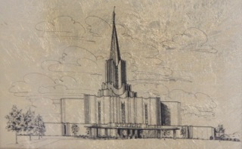
Christmas 2012

To my beloved Children and Grandchildren,

I wish to bear solemn witness that Jesus Christ lives. He is our Savior, our Redeemer, and the God of this earth. Through Him and through Him only may we be saved in the kingdom of God. Through our obedience to the laws and ordinances of the gospel and through the atonement of Jesus Christ, we will be able to enter the celestial kingdom and live with our Heavenly parents and all our faithful brothers and sisters who have kept their covenants and repented of their sins.

After you have gone down into the waters of baptism and have been given the Gift of the Holy Ghost, remember to attend your meetings faithfully and fulfill all church callings given to you by your church leaders, for they come from God and will be a great blessing to you and others.

Pay your tithing with a grateful heart that you are privileged to help build the Kingdom. Make sure all people recognize who you are and what you stand for. Do this by word and deed, with humility and love. Be faithful to all your covenants. Love and cherish your family. Teach them by example to be kind and generous. Treat your spouse as your equal companion in all things, for it is so. Be quick to apologize and repent, and seek to make your marriage strong and happy.

Learn all that you can, both temporal and spiritual. Study your scriptures daily that you may gain wisdom and knowledge and not be deceived. Listen to your leaders and always follow the prophet. Pray morning and evening, and keep a prayer in your heart all day long that you may be receptive to the promptings of the spirit which many times we miss by not listening. Act on those promptings, for I testify that whenever I have done so, they have proven right and blessings have come to me and others.

I testify that all these things will bring you happiness.
With all my love,

Douglas A. McConochie

